Primary Education Project
Diocese Of Hyderabad
July Updates 2017

Evaluations Preparation:
The evaluation has been confirmed to be held in September 2017.Communications with the donors for the 1st draft of TOR were done during July. All the required documents for the evaluation have been completed.
Seminar On House Of Prayers:
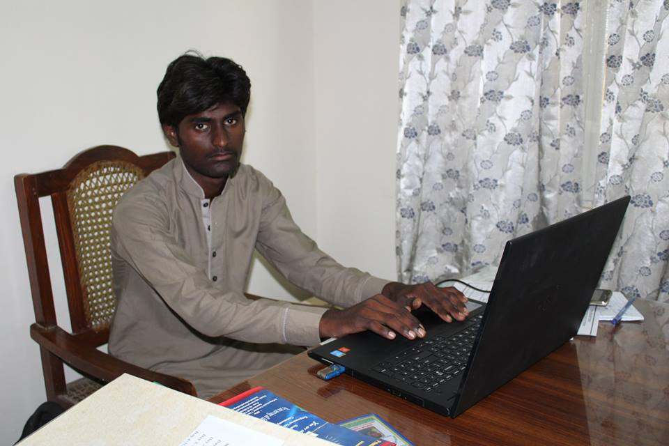
The seminar was held by the Tearfund's country representative Sir Ashraf Mall in July. The purpose of this seminar was to gather organizations and institutions supported by Tearfund to form prayer groups that could pray for their society, city and country. The seminar further discussed how to form groups and what to pray for. PEP has implemented the house of prayer idea in PEP office devotions.
Interns From Diocesan Boys Hostel Mirpurkhas:
Three interns from the Diocesan Boys Hostel Mirpurkhas were selected for three month internship from June to August 2017. Through Dick Kleinhesselink PEP was able to get International Support for the interns through ICCO.
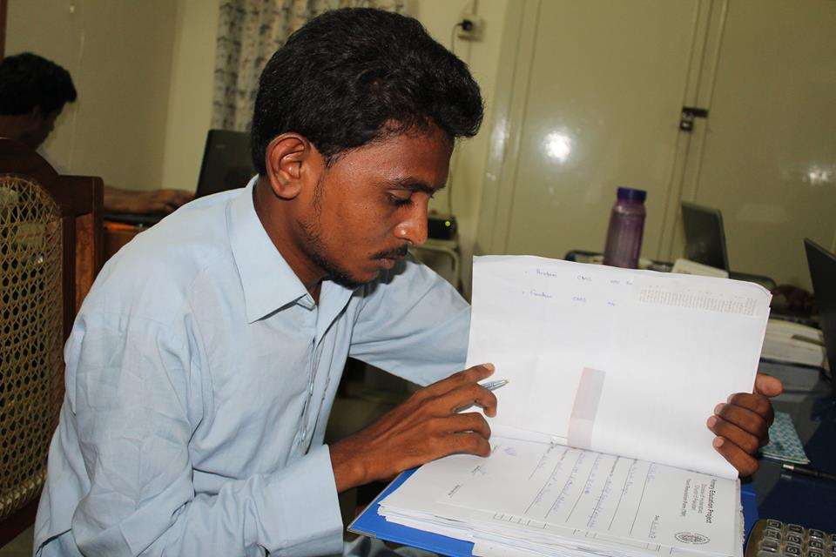
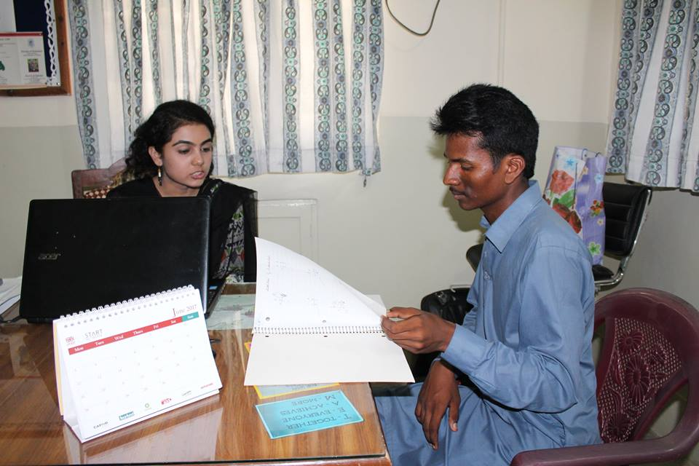
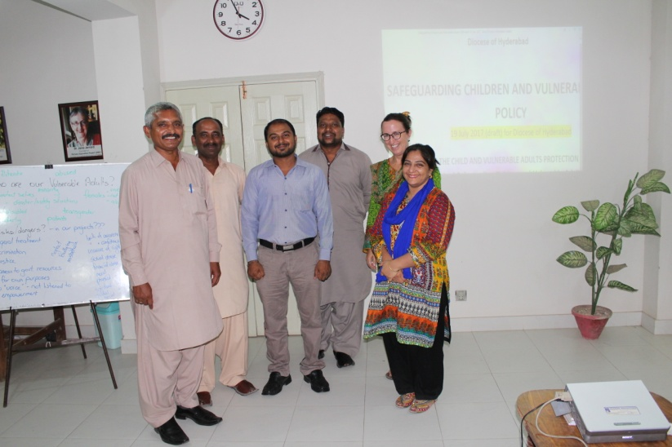
Child Protection Meeting:
The purpose of the Child Protection meeting is to develop an overall Diocese policy that has targeted two groups mainly children and vulnerable adults. The Child Protection meeting will be approved by the Diocesan board of education.

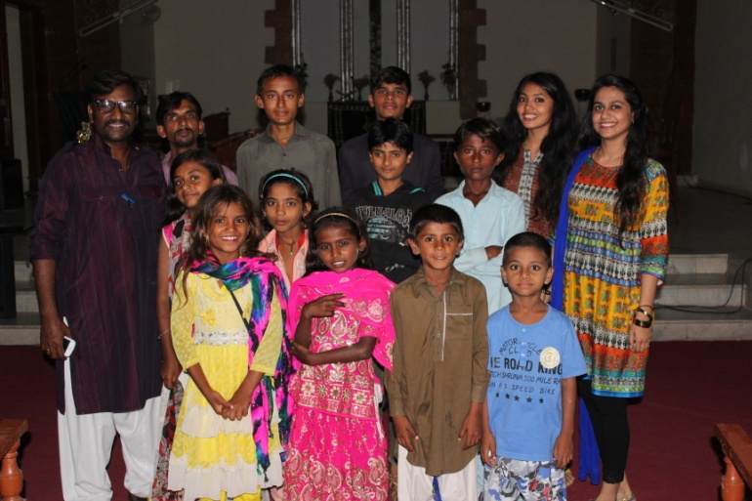
Children's Theater Preparation:
The children's theater is going to be prepared by Sir Munawar John who is leading the PEP CAP group. The children in this theater group are from the areas Mirpurkhas, Khowaja Goth, and Tando Ghullam Ali where PEP has its schools. This theater is especially being prepared for the independence day with a message for the youth which is to help youth understand their purpose and responsibility as a Pakistani. The children will perform theater throughout August, and later the children will also do a theater on Early Marriage that will be performed on independence day programme in Churches, Diocesan Office, Diocesan Institutions, and the Diocesan Hostels.

